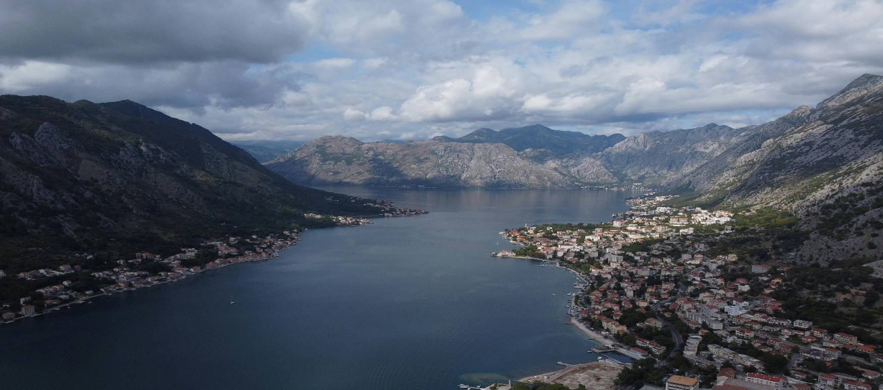

**NATHIA GALI**

**Nathia Gali: A Breathtaking Gem in Abbottabad, Khyber Pakhtunkhwa**

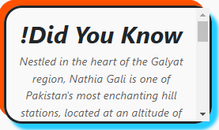Nestled amidst the majestic hills of Abbottabad in Khyber Pakhtunkhwa, Nathia Gali is a serene hill station that captivates visitors with its unspoiled beauty and tranquil ambiance. Located at an elevation of 2,410 meters (7,907 feet), this picturesque town is part of the Galyat region, a string of charming hill stations scattered across the Abbottabad District. Nathia Gali is renowned for its cool, refreshing climate, lush green landscapes, and awe-inspiring panoramic views of the surrounding mountains, making it a popular retreat for nature lovers, adventure enthusiasts, and peace seekers alike.  
The town's enchanting scenery is complemented by its rich biodiversity. Nathia Gali is home to dense pine, oak, and cedar forests that provide a natural habitat for an array of wildlife, including leopards, monkeys, and an impressive variety of bird species. Visitors are often greeted by the melodious chirping of birds and the rustling of leaves, adding to the area’s magical charm. Whether you're looking to explore its scenic hiking trails, enjoy a leisurely picnic in nature's lap, or simply unwind amidst the cool mountain breeze, Nathia Gali offers an unforgettable experience.

**A Haven for Adventure and Exploration**

For adventure enthusiasts, Nathia Gali serves as a gateway to thrilling outdoor activities. T

he hill station boasts several hiking trails that cater to both beginners and seasoned trekkers. One of the most famous trails leads to the Mukshpuri and Miranjani peaks, offering breathtaking views of the Himalayan ranges and the surrounding valleys. These trails meander through dense forests and meadows, providing a perfect blend of challenge and beauty.  
In addition to hiking, Nathia Gali’s serene environment makes it an ideal spot for camping and birdwatching. The region’s diverse flora and fauna add an element of excitement to any outdoor excursion. The refreshing mountain air and the opportunity to connect with nature make every adventure in Nathia Gali a rejuvenating experience. Whether you're scaling the heights of Miranjani or enjoying a quiet moment by a cascading waterfall, the hill station ensures you create memories that last a lifetime.

**Rich History and Cultural Heritage**

Beyond its natural allure, Nathia Gali has a rich historical and cultural significance. The town was a favored retreat during the British colonial era, with many remnants of colonial architecture still visible today. The charming cottages and bungalows scattered across the area offer a glimpse into its storied past. St. Matthew’s Church, a historical landmark constructed during the colonial period, is a must-visit site that stands as a testament to the town’s heritage.  
  
Nathia Gali also offers a unique cultural experience. The local markets are bustling with activity, where visitors can purchase traditional handicrafts, shawls, and souvenirs. The town’s culinary offerings are equally enticing, with a variety of local and regional dishes that provide a taste of authentic Pakistani flavors. From steaming cups of chai to hearty desi meals, the food scene in Nathia Gali is sure to satisfy every palate.

**A Perfect Year-Round Destination**

Nathia Gali’s charm isn’t confined to a single season. Each time of the year brings a new dimension to its beauty. In summer, the town offers a refreshing escape from the sweltering heat, with temperatures rarely exceeding 25°C (77°F). The lush greenery and vibrant flowers create a stunning landscape that soothes the soul. During the monsoon season, the area’s forests come alive with a mesmerizing mist that adds an air of mystery to the surroundings.  
  
Winter transforms Nathia Gali into a snowy wonderland, attracting visitors who wish to experience its magical white landscapes. The snow-covered trees and paths create a fairytale-like ambiance, perfect for cozy getaways. Spring and autumn, with their mild weather and colorful foliage, are equally delightful times to visit, offering a peaceful retreat for those seeking solace in nature.  
  
In conclusion, Nathia Gali is a destination that perfectly blends natural beauty, adventure, and cultural richness. Whether you're a nature enthusiast, a history buff, or someone looking to escape the hustle and bustle of city life, this enchanting hill station promises an unforgettable experience. Explore its scenic trails, immerse yourself in its rich heritage, and let the serenity of Nathia Gali leave you spellbound.

***ENJOYABLE ACTIVITIES***

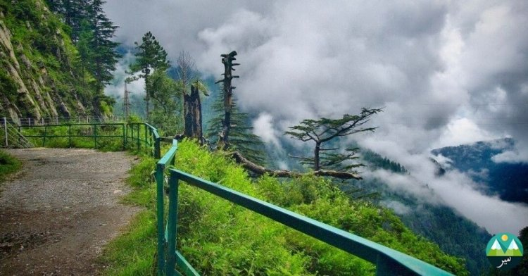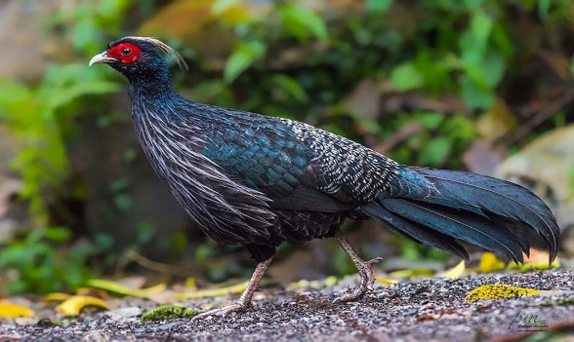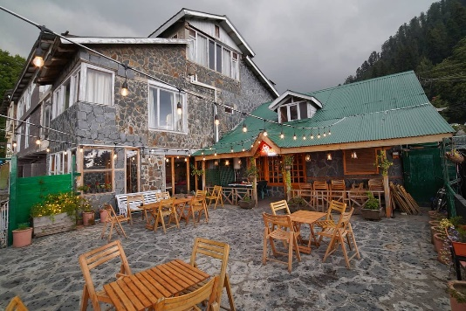

***! Picnics & Food – Relax at scenic spots or enjoy local treats like pakoras and karahi.***

***! Hiking Trails – Explore Mukshpuri and Miranjani trails with stunning views and serene nature.***

***! Wildlife Spotting – Catch glimpses of leopards, deer, and colorful birds in the lush forests.***

**Explore Nathia Gali: The Crown Jewel of Abbottabad, Khyber Pakhtunkhwa**

Nestled in the lush green hills of Abbottabad District in Khyber Pakhtunkhwa, Nathia Gali is a picturesque hill station that captivates visitors with its stunning natural beauty and serene ambiance. Located approximately 34 kilometers from Murree and 35 kilometers from Abbottabad, this enchanting destination is a favorite retreat for nature lovers, adventurers, and those seeking an escape from the hustle and bustle of city life. Sitting at an elevation of 8,200 feet above sea level, Nathia Gali boasts a cool and pleasant climate, making it a perfect getaway throughout the year.

A Paradise for Nature Enthusiasts Nathia Gali is renowned for its dense pine, oak, and cedar forests that create a canopy of greenery as far as the eye can see. The area is home to a diverse range of flora and fauna, making it a haven for eco-tourism and wildlife enthusiasts. Spotting wildlife such as monkeys, leopards, and colorful birds is a common delight for visitors exploring the region.

One of the standout features of Nathia Gali is its network of scenic hiking trails that lead adventurers through breathtaking landscapes. The Mukshpuri and Miranjani trails are among the most popular, offering panoramic views of snow-capped peaks, verdant valleys, and sparkling streams. Whether you're an experienced trekker or a casual walker, the trails cater to all skill levels, promising a memorable experience amidst nature's tranquility.

Rich History and Colonial Charm Beyond its natural beauty, Nathia Gali also carries historical significance. During British colonial rule, it served as a summer retreat for officials seeking respite from the heat of the plains. The remnants of colonial architecture, including charming cottages and rest houses, add a touch of nostalgia to the area. The historic St. Matthew’s Church, built in the late 19th century, is a must-visit landmark that reflects the town's colonial past. Surrounded by towering pine trees, this quaint church is a testament to Nathia Gali's timeless charm.

Activities and Attractions Nathia Gali offers a plethora of activities for visitors of all ages. From picnics at lush green meadows to horse riding along scenic pathways, there's something for everyone. Adventure seekers can indulge in paragliding, zip-lining, and rock climbing, while families can enjoy leisurely strolls and savor local delicacies at roadside cafes.

During the winter months, Nathia Gali transforms into a snowy wonderland, attracting tourists for its magical landscapes and opportunities for snow sports. Whether you’re building snowmen, enjoying a snowball fight, or simply soaking in the serene beauty, winter in Nathia Gali is an experience to remember.

**Discover Nathia Gali: A Tranquil Escape in Abbottabad**

Perched in the heart of the Galyat Range, Nathia Gali is a picturesque hill station located in Abbottabad, Khyber Pakhtunkhwa. Famous for its cool climate, breathtaking views, and lush greenery, this idyllic retreat offers visitors an unforgettable experience away from the hustle of urban life. Whether you’re visiting with family, friends, or solo, Nathia Gali promises a unique blend of natural beauty, adventure, and cultural richness.

Climate and Accessibility Nathia Gali’s pleasant weather is one of its biggest attractions. The summer months bring temperatures ranging between 16°C and 25°C, making it an ideal destination to escape the scorching heat. Winters, on the other hand, are cold and snowy, with temperatures occasionally dropping below freezing, creating an enchanting white landscape. Easily accessible by road from major cities like Islamabad, Rawalpindi, and Peshawar, the journey to Nathia Gali is as rewarding as the destination itself, with winding roads offering stunning views of the surrounding mountains.

Scenic Landmarks and Iconic Views One of Nathia Gali's most iconic landmarks is the Mukshpuri Top, a 2.5-hour hike from the main town that rewards trekkers with panoramic views of the Himalayan range and lush valleys. Another must-visit destination is Miranjani Top, the highest peak in the Galyat region, offering breathtaking vistas and a sense of achievement for those who make the climb.

For those who prefer a more relaxed pace, the Green Spot—a serene picnic spot—and the vibrant bazaars of Nathia Gali provide ample opportunities to unwind and immerse yourself in the local culture. The bazaars are filled with handicrafts, traditional clothing, and delicious food, allowing visitors to take a piece of Nathia Gali home with them.

Local Cuisine and Hospitality Nathia Gali’s culinary scene is a delightful blend of local and traditional flavors. From freshly grilled trout to warm pakoras enjoyed with steaming cups of chai, the food here is a treat for the senses. The local community is known for its warm hospitality, making visitors feel right at home. Many family-run guesthouses and hotels offer cozy accommodations with stunning views, ensuring a comfortable and memorable stay.

Plan Your Visit Whether you’re looking to reconnect with nature, embark on adventurous hikes, or simply relax in a tranquil setting, Nathia Gali has something to offer everyone. Its timeless charm, rich history, and natural beauty make it one of the most sought-after destinations in Pakistan. Don’t miss the opportunity to explore this jewel of Khyber Pakhtunkhwa and create memories that will last a lifetime.

**LOCATION**

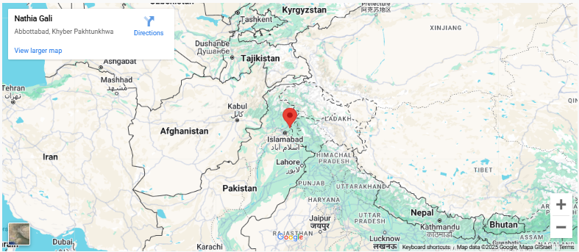

Nathia Gali is a hill station located in the Abbottabad District of Khyber Pakhtunkhwa, Pakistan. It lies about 100 kilometers (62 miles) from Islamabad and is part of the Galyat range in the Hazara region. Known for its pleasant weather, lush greenery, and stunning views, Nathia Gali is a popular tourist destination, especially for nature lovers and hikers.

**Why Visit Nathia Gali?**

**Nathia Gali, nestled in the heart of Abbottabad's Galyat region, is a destination that promises an unforgettable experience. Whether you're an adventure seeker, a nature enthusiast, or someone simply looking to relax, Nathia Gali offers something for everyone**

**FEATURED PRODUCT**



